Multistage in release:

We can add stages as below for the multiple environments.

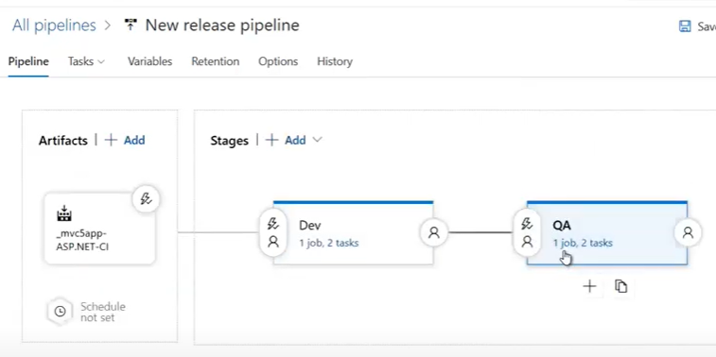

We can select the stage while triggering as below.

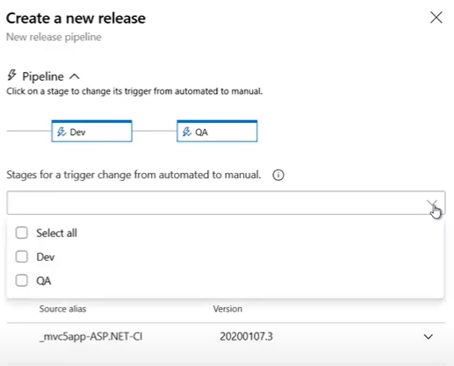

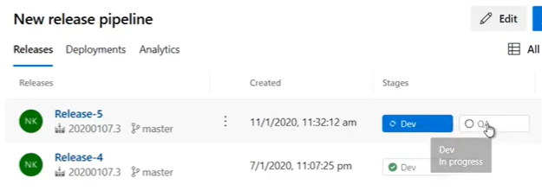

We can create the stages as below also.

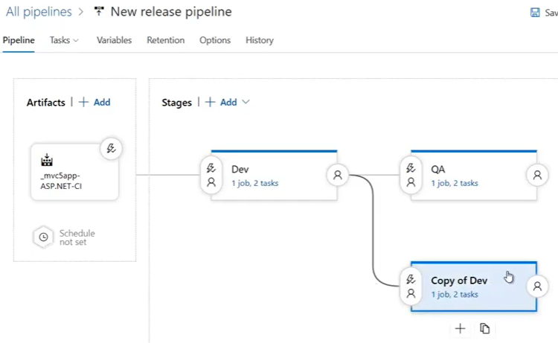

Triggers:

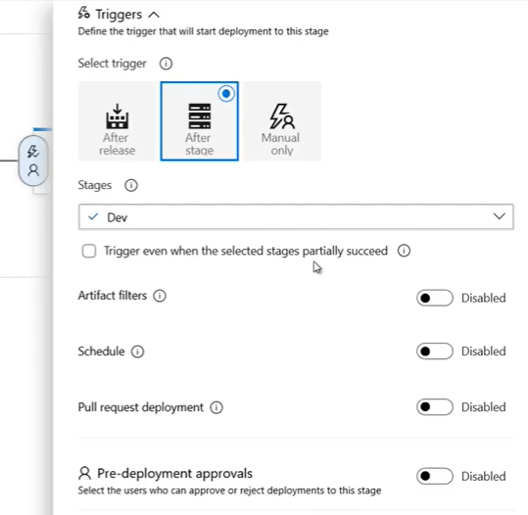

We need to select the “after stage” option as above to create triggers only on particular stage.